**Project report on Fresh Bites Catering**

1. Introduction:
   1. Overview:

Accounting plays an essential role in any business organization as it helps to record all transactions and analyse the financial status of the business at the end of the financial year.

In Zoho Books, we will see about item creation, vendor creation, customer creation, purchase order creation, sales order creation, creation of bills and invoice, creation of bank account, payment made to vendors through bank, payment received through bank, journal report, filing of GST.

* 1. Purpose:

The purpose of the project is to accumulate the report on financial information about the performance, financial position and cash flow of a business. To measure the process of a company financial statement overtime and see how it change.

1. Problem Definition and Design Thinking:
   1. Empathy Map:

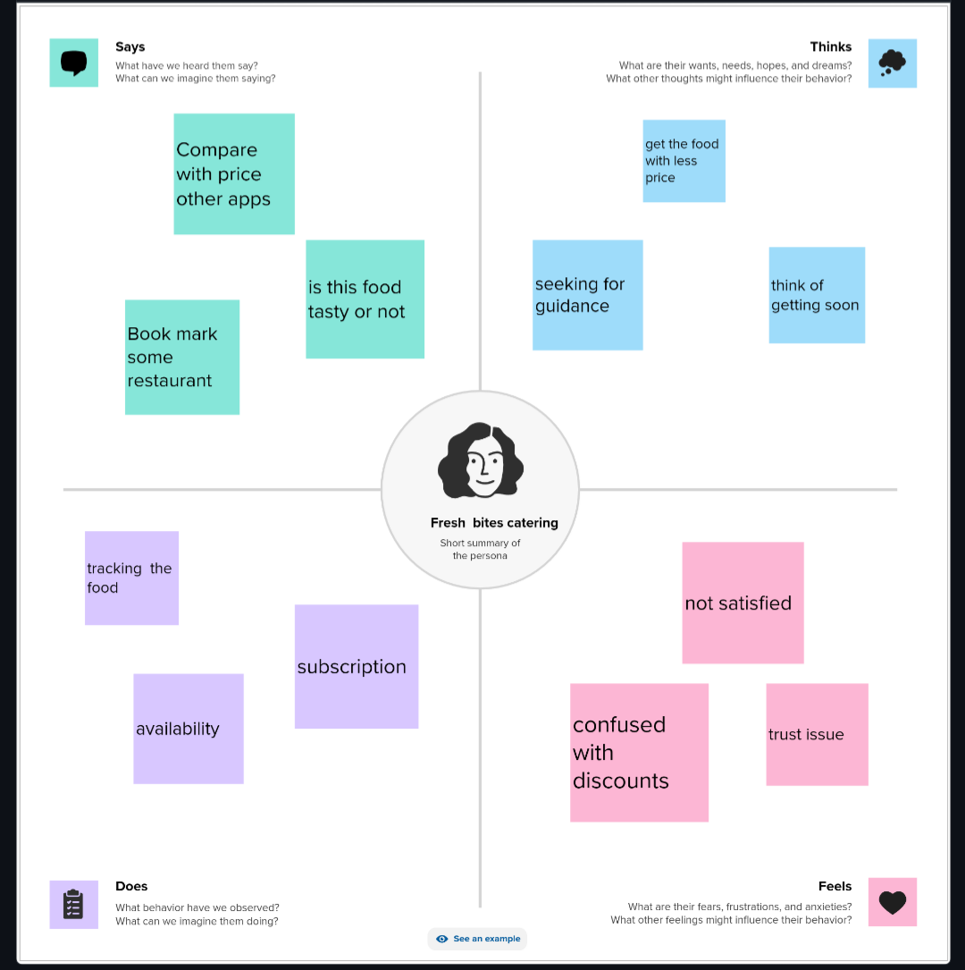

* 1. Ideation and Brainstorming Map:

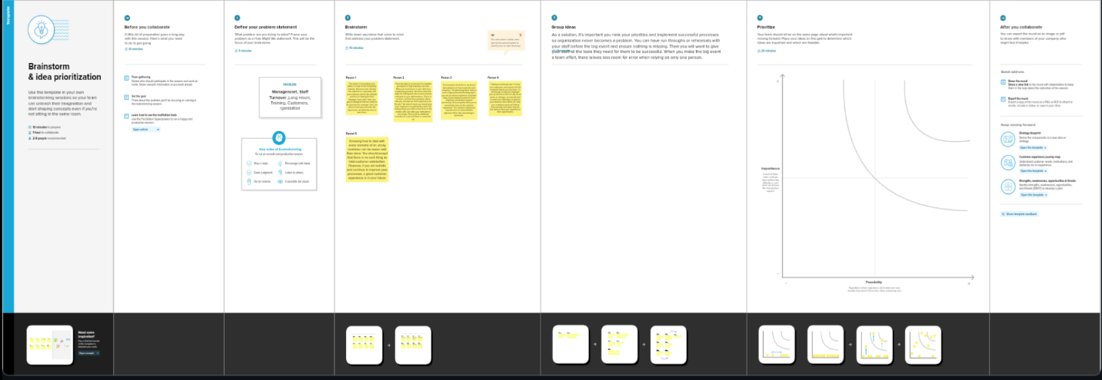

1. Result:

Balance Sheet:

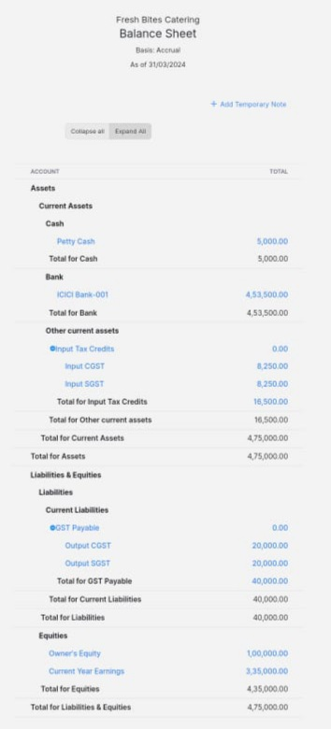

Accounts Receivables:

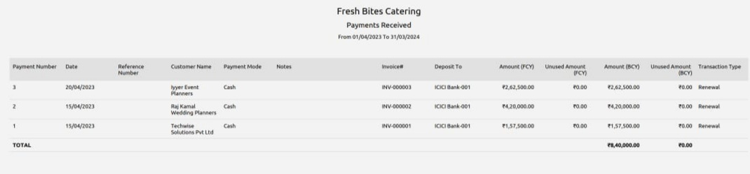

Profit and Loss Account:

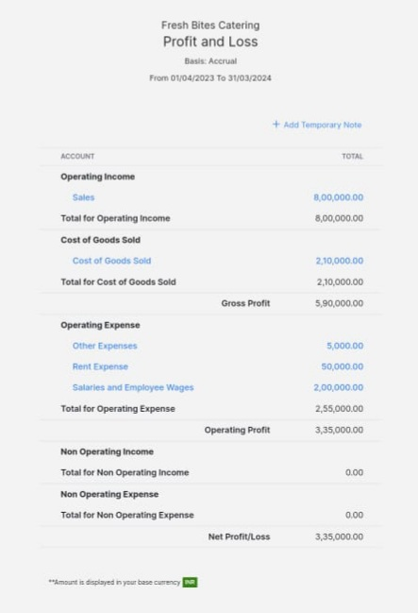

Accounts Payable:

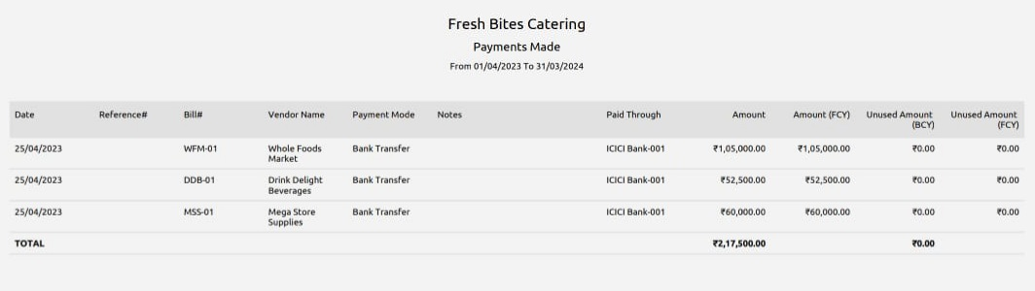

Banking:

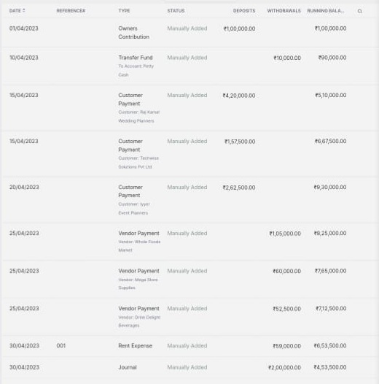

Journal report:

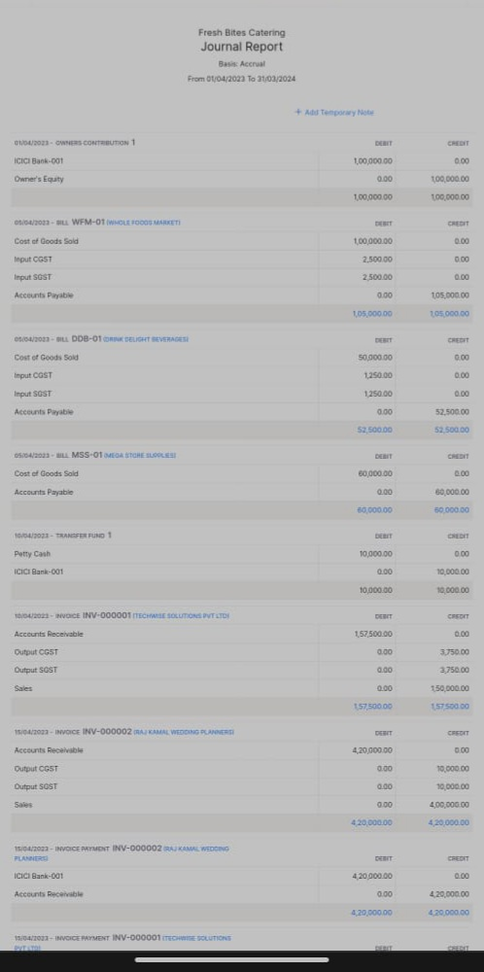

GST:

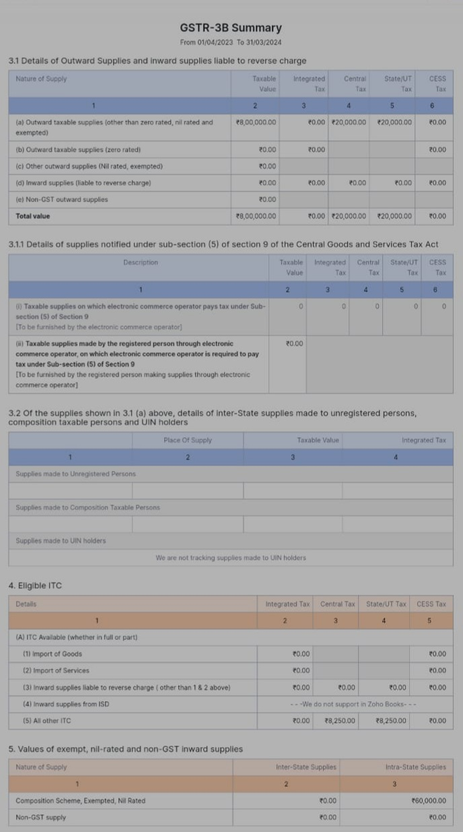

Petty Cash:

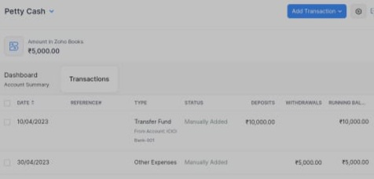

1. Advantages and Disadvantages:

Advantages:

1. Cost-Effective:

Zoho Books offers various pricing plans, making it cost-effective for small and medium-sized businesses in the food industry, which may have limited budgets.

1. Easy to Use:

It has a user-friendly interface, making it accessible for business owners and staff who may not have extensive accounting experience.

1. Inventory Management:

Zoho Books includes inventory management features that can be beneficial for businesses dealing with perishable food items or tracking ingredient costs.

1. Integration:

It integrates with other Zoho apps and third-party software, allowing you to connect with point-of-sale systems, e-commerce platforms and more.

1. Expense Tracking:

You can easily track and manage expenses related to sourcing ingredients, equipment, and other operational costs.

Disadvantages:

1. Limited Scalability:

Zoho books may not be suitable for large food industry businesses with complex accounting needs.

1. Lack of Specialized Features:

It may not offer industry-specific features required by some food businesses such advanced recipe costing or nutritional analysis.

1. Customer Support:

While Zoho provides customer support, some users have reported delays in response times, which can be frustrating if you encounter.

5. Conclusion:

From this project it is clearly indicates that, a summarized a financial statements, which supply an overview of the financial activities of business among a period such as Assets- Rs. 4,75,000 Liabilities – Rs. 4,75,000    Bank balance – Rs. 4,53,500     Cash balance – Rs. 5,000      Trade Payable – Rs. 2,17,500        Trade receivable – Rs. 8,40,000       Cost of goods sold – Rs. 2,10,000       GST payable – Rs. 40,000       GST receivable – Rs. 16,500        Operating income – Rs. 8,00,000    and Operating expenses – Rs. 2,55,000        during the year, as well as information about its financial position on a specific date. Furthermore, financial statements help owners in evaluating the performance and position of their business which can guide their investment decisions and also accounting also helps organizations to plan their finances by developing budgets and forecasts. This process helps organizations in planning their finances ahead and controlling   any deviations from the budget. Lastly, accounting is a trustworthy process for recording, organizing and analysing financial information which helps in the effective management of the business.

6. Future Scope:

This project will be helpful to business plan for the future by providing insight into how much money they have and how much money they will need. It also tracks the performance of a business and helps to make a crucial decision about in future.